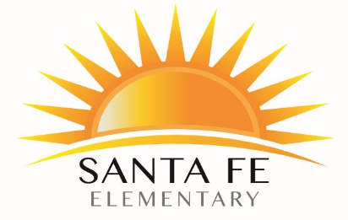
Student Name Teacher Name
Santa Fe Elementary School
Title I Student-Parent-School Compact 2023-2024

In order for your child to achieve high standards of conduct and accomplishments that parents and the staff desire, we must all work together as a team. We are asking you and your child to participate on our team and to accept the following responsibilities. Please discuss with your child the importance of this program. Sign and return the compact to your child's teacher ASAP.
As a student, I pledge to…
- Attend school regularly
- Do my best while at school
- Help keep my school safe
- Ask for help when need it
- Respect and cooperate with others
As a parent, I pledge to...
- Have my child attend school regularly
- Notify staff if child will be absent from school
- Check on my child's schoolwork daily
- Set high expectations for my child as an individual
- Read with my child 20+ min each day
- Participate in parent activities at Santa Fe
- Pick my student up on time
The staff at Santa Fe pledges to...
- Set high expectations for themselves and their students
- Strive to make every child successful
- Communicate progress to parents
- Provide materials for students to use at home

Student signature Parent Signature
Thank you for your support and participation in
your child's education! - The Santa Fe Staff

